Food Pyramid in the 70s
Student Name
Institution Affiliation
October 23, 2017

The past 50 years in Nutrition: Why the food pyramid of the 70’s had it all wrong…and how we are paying for it.

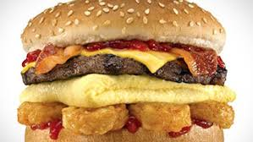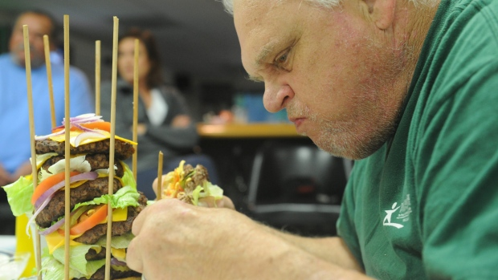
http://www.wcvb.com/image/view/-/20515642/medRes/4/-/maxh/460/maxw/620/-/gts7wgz/-/Gross-Foods---Carls-Jr-Breakfast-Burger-http://www.cbc.ca/gfx/topvideo/2014/elke-burger-challenge.jpgjpg.jpg

#1 What if it’s all been a big fat lie?
http://www.nytimes.com/2002/07/07/magazine/what-if-it-s-all-been-a-big-fat-lie.html?pagewanted=all
- When did Atkins publish his “Diet Revolution” book?
Dr. Atkins published his “Diet Revolution” book in 1972.
- According to the Atkins diet what has been causing the rise in obesity in America?
The rise in obesity in America, according to Atkins diet is caused by low fat and high carbohydrates content in the American diet.
- Walter Willett, chairman of the department of nutrition at the Harvard School of Public Health, may be the most visible proponent of testing his “heretic” hypothesis. According to his research, when did the obesity (and diabetes) epidemic being?
It began in the early 1980’s.
- What is endocrinology?
This refers to the study of medicine or branch of physiology that deals with the endocrine system,
That is, the glands, its diseases and hormones.
- According to David Ludwig, a researcher at Harvard Medical School who runs the pediatric obesity clinic at Children's Hospital Boston, “Endocrinology 101” requires an understanding of how carbohydrates affect what?
It requires an understanding of how carbohydrates affect blood sugar and insulin which in turn affect appetite and fat metabolism.
- Why does the author claim that “it's possible to find at least some published research to support virtually any theory”?
This is because researchers study prefer studying something less costly and more controllable hence end up studying oversimplified experimental situations with unrealistic results.

- Type 2 diabetes often accompanies obesity. It used to be called adult-onset diabetes and now, for the obvious reason, is not. Why?
This is because of the change in our lifestyles over the years such as eating junk food, children
Spending the whole day inside the house, lack of exercise and presence of the thrifty gene hence
Type 2 diabetes is even more common in younger generation now.
- Compare the thrifty gene to the spendthrift gene.
The thrifty gene is more of about how storing extra calories as fat is an evolutionary advantage to our ancestors who had to survive frequent famine while the spendthrift gene is concerned with the opposite, that is evolutionary advantages of losing weight effortlessly.
- Why is this theory of weight gain and inability to lose weight and keep it off untestable?
It’s untestable because it is extremely costly to conduct research on a sizeable population like
The one in the United States and also it would violate people’s rights if proper research is to be conducted.
- It is also undeniable, note students of Endocrinology 101, that mankind never evolved to eat a diet high in ______starch or sugars_________________
- Until the late 70's, the accepted wisdom was that fat and protein protected against overeating by making you_____sated_________
- It was Ancel Keys, paradoxically, who introduced the low-fat-is-good-health dogma in the 50's with his theory that dietary fat does what?
In his theory, dietary fat raises cholesterol levels and gives the victim heart disease.

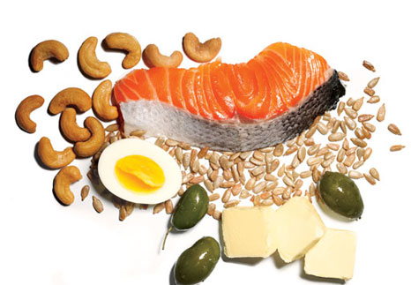
http://femalefitnesstrickytips.com/wp-content/uploads/2013/01/which-are-bad-fats-281x300.jpg
http://www.womenshealthmag.com/sites/womenshealthmag.com/files/images/1205-fat.jpg

#2 The truth about fats: the good, the bad, and the in-between

http://www.health.harvard.edu/staying-healthy/the-truth-about-fats-bad-and-good
- Why did a switch in low fat foods not make the public healthier?
This is because as people cut back on bad fats they also stopped taking healthy fats which are essential for the body.
- Why are fats necessary in our diet?
They are a major source of energy for the body and in addition to that help in absorption of minerals and vitamins, it sheaths nerves, aids in building cell membranes and vital for muscle movement, inflammation and blood clotting.
- What are the “bad” fats and “good” fats?
The bad fats are the industrial made trans fats which are byproducts of hydrogenation where hydrogen and metal catalysts are added to make it solid hence making them unhealthy while good fats are those from vegetables, nuts and fish and have less hydrogen atoms. These could be monounsaturated (have single carbon to carbon double bond) or polyunsaturated (essential fats made of omega-3 and omega-6 fatty acids).
- With regard to structure, what makes one fat different from another?
The different fats differ in the number of hydrogen atoms surrounding each carbon atom. For instance, in saturated fats the chain of carbon atoms holds as many hydrogen atoms as possible while in good fats they hold only a few hydrogen atoms.
- What is hydrogenation and what is it’s the purpose?
This refers to the process of heating vegetable oils in the presence of hydrogen and heavy metal catalysts to add hydrogen atoms to the carbon chain so as to turn it to solid and prevent the oils from becoming rancid.
- What is the safe level of consumption for Trans fats?
They have no safe level of consumption since even as little as 2% of calories from these fats increase the risk of heart disease by 23%.
- Healthy fats are generally __liquid____at room temperature
- What are the differenes between monounsaturated and polyunsaturated fats?
Monounsaturated Fats | Polyunsaturated Fats
Have single to single carbon to carbon double bond. | Have two or more double bonds in the ir carbon chains
Sources are nuts, avocados, olives and sunflower | Sources include fish(omega-3), nuts and soybeans
Are heart friendly | Have more benefits including reducing dementia, aid in blood clotting and muscle movement.

- Olive oil is an example of a ______mono____unsaturated fat.
- Fats that your body can not make but are required for normal bodily functions are called what?
They are referred to as essential fats.
- What are the two main types of polyunsaturated fats?(2 points)
They are omega-3 fatty acids and omega-6 fatty acids.

#3 The Great Grain Conundrum
http://toxipedia.org/download/attachments/17044484/Report%20%2318%20-%20Great%20Grain%20Conundrum.pdf?version=1&modificationDate=1388194221000&api=v2
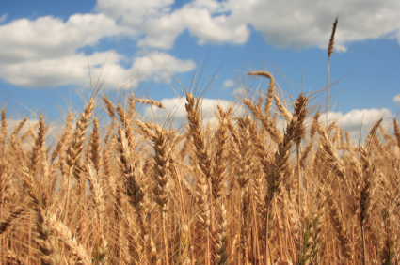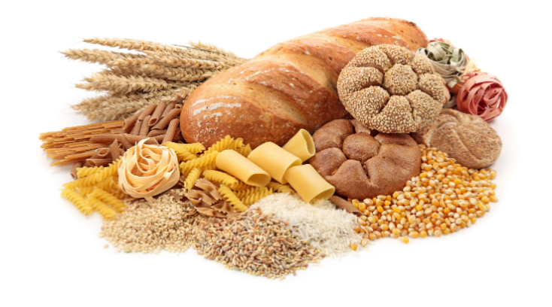https://encrypted-tbn0.gstatic.com/images?q=tbn:ANd9GcSQEp_JdL-a3jL9vnNn0PpcW2qrfxvz5IHe9DZcOb5nqiiyLUFtdA,http://bonfirehealth.com/wp-content/uploads/2011/09/grain.jpg
- According to the author, how has the scientific community changed its position on wheat and other grains?
The scientific community, from their research now discourage intake of wheat and other grains due to the number of compounds and proteins found in these grains and their toxic effect on the human body.
- What are anti-nutrients?
These refer to synthetic or natural compounds that interfere with the absorption of nutrients in the human body and in this case include gluten, phytic acid among others.
- What foods contain phytic acid and what are the 3 adverse effects of this protein?
Phytic acid is found in grains, beans, seeds and nuts and its adverse effects include:
- It traps phosphorus hence making it unavailable to the body.
- It inhibits mineral absorption such as zinc hence causing mineral deficiencies.
- Also it interferes with enzymes such as pepsin, amylase and trypsin which are needed in food digestion.
- What probiotic produces phytase?
It’s produced by probiotic lactobacilli.
- Which antinutrients can contribute to suppression of thyroid activity?
Goitrogen compounds.
- Gluten is actually a compound of two storage proteins. What are they?
It’s a compound of prolamin and glutelin.
- According to the article, there are several types of gluten which vary from grain to grain. However, by definition “technically” gluten is a term applied specifically to the prolamin-glutelin combination found in what?
It’s a term applied to the prolamin-glutelin combination found in wheat.
- Which prolamine has been implicated as the main environment factor in causing Celiac disease?
Gliadin is the main factor causing celiac disease.
- What is damaged in Celiac disease?
It damages the villi of the duodenum and jejunum.

- Symptoms of Gluten sensitivity are similar to celiac disease. What are these symptoms?
The symptoms are abdominal pain, fatigue, headaches, autism, a “foggy mind”, schizophrenia and tingling in extremities.
- Gluten molecules are resistant to the enzymes that break down proteins. What are these enzymes called?
They are referred to as peptidases.
- According to David (2010) what explains the rise in Celiac disease since the 1960s?
This was caused by the change in wheat we consume. The gluten proteins in modern wheat differ considerably from those found in wheat in 1960 due to genetic modifications.
- What causes a “leaky gut”?
This is caused by gluten’s inflammatory effect in the gut/intestines which leads to premature death of intestinal cells hence their oxidation leading to intestinal permeability (leaky gut).
- A leaky gut can allow __bacterial proteins______ and other toxic compounds to enter in to the blood stream and general circulation.
- Gliadin can be similar in structure to other proteins found in tissues of such organs as the _thyroid______ or the ____pancreas_______.
- The most common nutritional deficiencies in gluten intolerance and Celiac disease are: Iron, folate and vitamin B12.
- (Please Scroll down to section entitled: “Amylopectin A”) The most digestible form of amylopectin is amylopectin-A, found in wheat. Because it is the most digestible, it is the form that most rapidly increases blood sugar. This is why, gram for gram, wheat increases ___blood sugar___ to a greater degree than, say kidney beans or potato chips. Or in other words, wheat products are no better and are often worse, than even simple carbohydrates such as __sucrose__________.
- The higher the blood glucose after consumption of food, the greater the insulin level, the more __fat_______ is deposited.

#4 Leaky gut: what it is and how to heal it
http://health.usnews.com/health-news/blogs/eat-run/2014/03/06/leaky-gut-what-it-is-and-how-to-heal-it
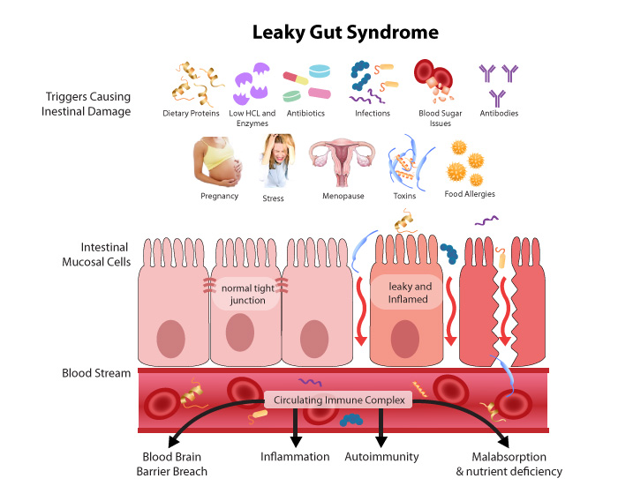

- In order for the vitamins and minerals to be absorbed, the small intestine contains
____microscopic pores_____so the nutrients can be transferred into the bloodstream.
- The problem with leaky gut is it causes the pores in your intestine to ___widen________.
- How does an increase in pore size in the intestine lead to allergies?
This is because when they widen, unwanted substances such as undigested food particles and toxins make their way in to the bloodstream. Since they are foreign, the immune system responds with an attack and build up antibodies to destroy them but since its gone haywire it ends up attacking healthy cells too unknowingly hence allergies and other autoimmune disorders develop.

- According to the article, what are two ways to develop a leaky gut?(2 points)
- During constipation, the toxins in the stool irritate the intestinal linings leading to inflammation hence the pores in the small intestine expand.
- Also, imbalance of flora in the gut-when the bad bacteria exceed the good in the gut-irritation and inflammation occur causing intestinal pores to open up.
- According to the author, what are three ways to heal a leaky gut?
This can be achieved by:
- Taking glutamine, an amino acid with the ability to heal the intestinal lining.
- Taking probiotics which have good bacteria that can restore balance of the gut flora.
- Taking fermented foods or even yoghurt which can counter causes of a leaky gut.

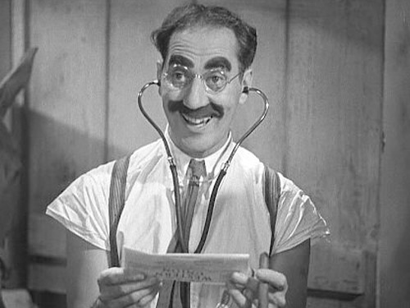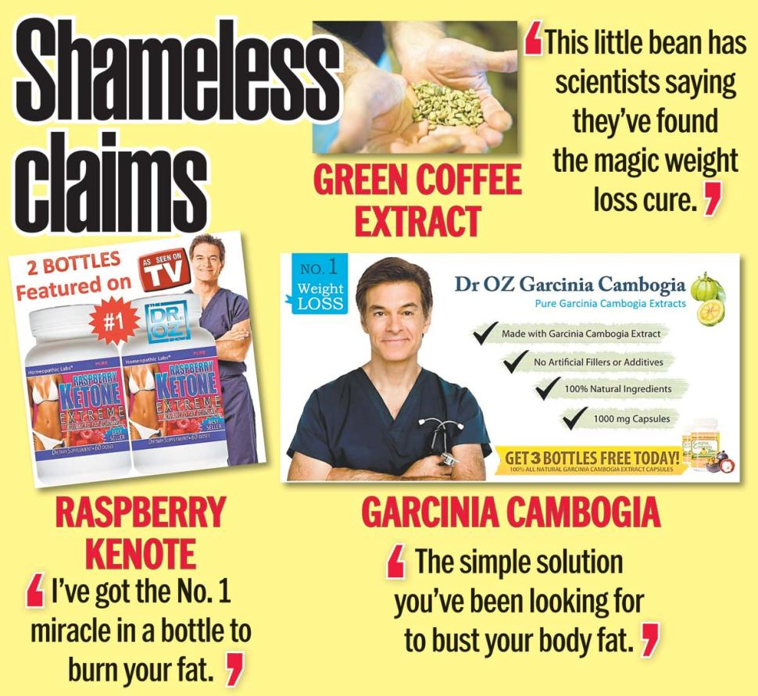
http://12840-presscdn-0-47.pagely.netdna-cdn.com/wp-content/uploads/2014/06/marxundiacarreras.jpg http://maxresultstraining.com/wp-content/uploads/2015/04/dr.-oz-claims.jpg

#5 Quacks or good advice?
http://www.alternet.org/personal-health/four-biggest-quacks-plaguing-america-their-bad-claims-about-science
- Why did the FDA send Dr. Mercola warning letters?
They did this since they didn’t approve of his unscientific medical claims and activities such as marketing products as having the ability to provide exceptional countermeasures against diabetes, cancer, heart diseases among other illnesses.
- According to the author, what are three claims against Mercola?
- The first is that AIDS doesn’t exist and isn’t caused by HIV but results from psychological stress from the belief HIV is harmful.
- Also he claimed Microwave ovens emit radiation and microwaving food alters its chemical structure.
- Finally, that commercial sunscreens increase the chances of getting skin cancer.
- According to the author, what are three claims against “the health ranger”, Mike Adams?
These are:
- That not guns but medications kill people.
- That Americans are constantly affected by lead emitted from airplane chemtrails.
- And finally that there is an invented cold fusion device which will be a game changer in the energy sector.
- According to Dr. David Gorski, Why is the “Food Babe’s” strategy effective?
It’s effective since her audience are illiterate about chemicals and once they hear some of the names of the chemicals it results to fear hence their automatic support to her agenda.
- Gorski says since companies live and die by public perception, it's far easier to “give a blackmailer like Hari what she wants than to try to do what?
Than to try to counter her propaganda by educating the public.
- According to the article, what does Vani Hari claim happens to water when exposed to the word “Hitler”?
She claims the water changes its physical property.
- ​Dr. Oz is professor at the Department of Surgery at Columbia University, directs the Cardiovascular Institute and Complementary Medicine Program at New York-Presbyterian Hospital, has authored more than 400 medical research papers and holds several patents. Why is he included in the author’s list of “Quacks”?
This is because he uses his influence and popularity to market worthless products with no proven scientific research. Despite his medical expertise he also embraces other quacks such as the likes of
Adams on his show who are an anathema to science and gives people false hope promoting all types of modern shamanism such as inviting a faith healer and a medium to his show.

